Dynamic Unit
1234 Main St, Naperville, Illinois 60955
312-123-456
tmonacochrsitopher@student.morainepark.edu
www.findyourriffle.com/index
Visual Design Specifications

Prepared for: Do It Now Painting
Pepared by:

Team Syntax
March 27th , 2021

Tatiana Monaco: Project Manager
Williams : Technical Lead & Web Production Specialist
Logan : Creative Lead
All : Quality Assurance

Table of Contents
Design Style Error! Bookmark not defined.
Global Elements 3
Page Specific Elements 5
Technical Specifications 6
Introduction 6
Global Elements 7
Template 9
Page Specific Elements 10
Naming Conventions 12
Programming 13
Approval 13
Functional Specifications 14
Summary 14
Assumptions 14
Global Elements 14
Page Specific Elements 14
Approval 15
File Structures 16

Design Style for Do It Now Painting

Global Elements

Page Dimensions
Media queries:
- 576px, max-width 540px
- 768px, max-width 720px
- 992px, max-width 960px
- 1200px, max-width 1140px

Headers
- Logo Dimensions – 100px x 100px
- Banner Dimensions – 384px x 300px
- Nav – Nav bar fixed at top of page, 667px x 176px

Colors

#D5EDF2
#627324
#858E58
#A69C6D
#650000

- Background: #FFFFFF
- Accents: #650000, #858E58
- Text: #00000 – Hover #650000

- Header: Background #A69C6D – Text #00000
- Text Boxes: #650000, #858E58, #D5EDF2
- Footer: Background #A69C6D – Text #00000

HTML Text
- Navigation Text – font-family: Arial, Sans-serif
- Jumpin’ Java Café Text – font-family: Garamond, serif
- Body Text – font-family: Times New Roman, serif
- Footer Text – font-family: Times New Roman, serif
- H2(font size) – 96px, Text #00000
- Nav(font size) – 12px, Text #00000
- Paragraph(font size) – 20px, Text #00000

Graphic Types
- Uppercase and lowercase text is acceptable
- The fonts already chosen are acceptable and web safe fonts
- No new fonts may be introduced

Photo/Image Treatments
- Images selected for the site must be high quality
- All images shall be optimized for the web
- Gutters may be 20px, 25px, or 30px

Enhancements
- Links will be used on the Navigation Bar. Font size for navigation text is 12px and hover color is #650000.
- We currently have two image placeholders on the page with dimensions of 220px x 170px.
- We have a Leave a Comment link that has the hover color set to #650000 and a float left property as well as a set width.

Page Specific Elements

Home Page
- Header and Footer will have the same color element. #A69C6D
- Banner Width, Logo and Dynamic Unit. Banner size 668px x 300px. Text color #00000 and Text size 92px. Logo 100px x 100px
- Navigation will consist of Home, Services, Team, Portfolio, Contact Us, Log in-Client-Employee. Text size will be 32px, color #00000 with a hover color of #627324
- Background color will stay #FFFFFF
- 20-25 px between top and bottom of images
- 30-35 px between side by side
- Description text within elements is 20px font
- Footer will hold social media icons and reviews, along with our address, email and phone number.

Services Page
- Banner from home page will also be applied to About Us page.
- Two images will be applied to this page 700px x 400px
- Boxes will be rectangular and uniform in size and follow color palate used for the page.
- Mission Statement heading will be an H2 heading with a 24px font
- Services offered will be an H3 heading with a 16px font

Team
- Menu will be written with H1 heading and 32px font
- 3 jpg images will be on page with Bios.

- Image size will be 100px x 100px
- Gutter between photos not to exceed 20-25px
- Colors will follow color palate

Portfolio Page
- Websites link and Logos will be written in H1 heading with 32px font
- Two images in jpg format 700px x 400px of screenshots of previous made sites
- Gutter between photos not to exceed 20-25px
- 5 images of logos previously made
- Contact us button and form on bottom of page
- Send message button
- Colors will follow color palate

Contact Us Page
- Banner from home page will be included on this page on right-hand
- Contact Us will be written in H1 heading and 32 px font
- There is one jpg image of envelope/contact 700px x 400 px
- Questions/comments area text box size 300px x 100px with submit button
- Customer send message area with text box area 300px x 100px
- Colors will follow color palate

Log Ins Page
1.Client 2.Employees
- Very Large Background Image of a Grey Keyboard on entire page
- Identical log in areas, 1.Client 2.Employees

- Contains username (required) password (required) Identical in both log areas

Technical Specifications
Introduction
This document provides Dynamic Unite Web designers with the specifications to help assist in creating user friendly web pages for Do It Now Painting. With these specifications Dynamic Unit will create a responsive, clean, easy to navigate site that will be well-organized with imagery, text, and include a top-notch home page for high-ranking SEO.

Technical Summary
- Shall only use client-side scripting languages, HTML5, CSS, and JavaScript.
- All pages shall have Meta Description Tag, Meta Keywords, and a Title page.
- All pages shall be validated using the W3C Standards.
- All pages must adhere to the W3C Standards for accessibility.
- All pages shall run without error in Chrome, Firefox, Internet Explorer, Opera, Edge, and Safari.
- All pages shall be designed for an optimum 1024 x 768 screen size.
- JavaScript must run without error in all current browsers.
- Use of the “alt” tag shall be used on all images.
- All images shall be optimized for the web and in .jpg format.
- Logo shall be in .png format.
- All forms shall be in PDF format.

Assumptions
Do It Now Painting will provide Dynamic Unity Web Designs with their PDF forms, .jpg images, and written text content. Do It Now is responsible for setting up and maintaining their own web host. All information listed in this document, once signed, shall be implemented, and adhered to.

Global Elements
The page structure shall be consistent, and each page shall contain:

- Header with logo to the right and NO drop-down navigation in the middle.
- Company name located header top left.
- Tick Grey border in all pages, except Log In Page
- Main content located within a scrollable body and have a clear visual hierarchy to the elements on each page.
- Footer with (maybe some if they have socials) social media links to the left, address/email/phone number in the center.
- Clients chosen color scheme and Sans Serif and Garamond fonts shall be on each page.
Global Elements

Global Header & Global Navigation
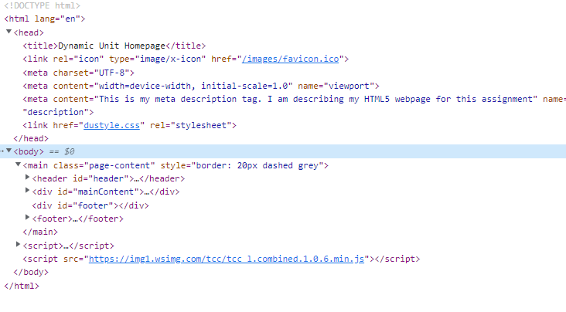
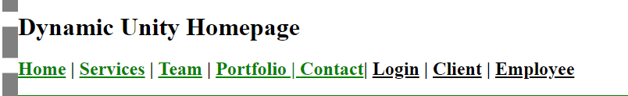
Global Footer
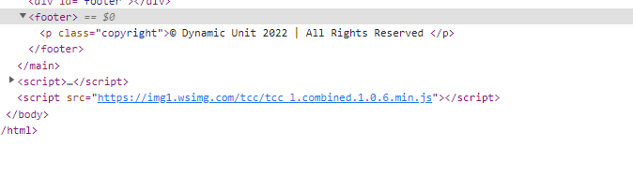
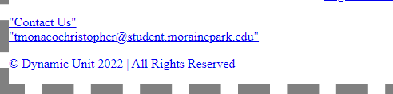

Template

#D5EDF2
#627324
#858E58
#A69C6D
#650000

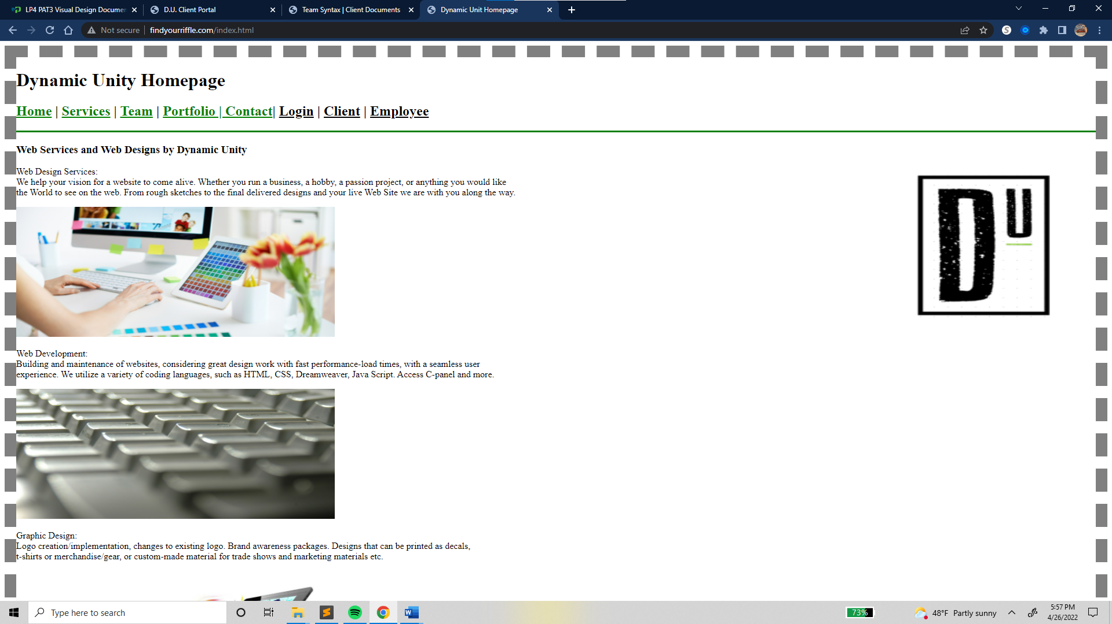

Page Specific Elements
Home Page
For both visual elements and functionality, the entire site will be consistent with the homepage.

Header
- Logo located right in .png format.
- The navigation bar located center.
- Home
- Services
- Team
- Portfolio
- Contact Us
- Log in -> 1. Client 2. Employee Areas

Main Content
- Below the header the company name will be displayed on top.
- Three sections will be directly underneath the company name.
- Text of what we do-Web Services + 1 Image.
- Text of Web Development + 1 Image.
- Text about web graphic design + 1 Image

Footer
- Contact us on left
- Email/phone number also left.

Services Page
This page will give users/potential customers an insight to what we do.
- Do It Now mission statement.
- What they offer in services and for the community of Chicago downtown.
- The webpage will contain two images in .jpg format.

Team
This page will address …………CONTENT ………

Portfolio Page
This page will address all the upcoming This page will feature:
- A calendar with future and past events and will be updated solely by Do It Now.
- More content goes here TBD
- This page will also display two images in .jpg format.

Contact Us Page
This page will feature:
- Hours of operation
- Address
- Email
- Phone number
- Two images in .jpg format
- Two forms.
- Questions/Contact Us with a text box area and submit button.
- Customer reviews with a text box area.

Naming Conventions
- File names should be short but descriptive. (long file names do not work well with all types of software)
- Avoid special characters or spaces (!, @, #, $, %, &)
- Use capitals and underscores instead of periods or spaces or slashes.
- Format for date designations is YYYYMMDD or YYMMDD (This format makes sure all of your files stay in chronological order, even over the span of many years.)

Example: doitnow.html (lowercase, no special characters, no spaces)

File Types and Extensions

File Type | Typical Use | Extension
HTML Document | Web page | .html
CSS Document | Web Page | .css
JPG | Photos/image | .jpg, .jpeg
PNG | Graphic, images (transparency) | .png, .gif
PDF | Documents that cannot be edited | .pdf
Word | Editable documents | .docx, .doc

Navigation Labels
- Home
- Services
- Team
- Portfolio
- Contact Us
- Log Ins

Programming
Document Type Declaration
<!DOCTYPE HTML>

Languages
- HTML
- CSS
- JavaScript

Development Tools
- Brackets
- Notepad++
- Adobe Photoshop
- Microsoft Office
- GoDaddy Hosting
- W3C HTML Validation
- W3C CSS Validations

- WAVE accessibility tool

Approval

Client Signature

X Rodrigo Lima Date __4/13/22___
Client Print Name

X Rodrigo Lima Date __4/12/22___
Client Signature

Dynamic Unit Web Design

X Tatiana Monaco Date ___4/12/22___
Dynamic Unit Signature (Project Manager)

Functional Specifications

Summary
This is the functionality report for Do It Now, made by Dynamic Unit. The goal for this website is to be able to navigate easily and be user friendly. There will be an inviting aura about the page and visually appealing. There will be many different pages but will be well organized and streamline and use of some pictures.

Assumptions
This page will be accessible and easy to navigate and use on any device. (pc, tablet, phone)

Global Elements
Consistency on each page including the color palate, header and footer and thick border.

Page Specific Elements
Home Page
The Navigation bar includes Home, About Us, Menu, Events and Contact Us. The body will include two images and information about Jumpin’ Java Café. The footer will include (4) social media icons, a link to the reviews as well as review stars and our address, email and phone number.
Service Page
About Us will include Jumpin’ Javas Café’s mission statement and what they offer in services and for the community of West Bend. It will also give users insight as to who the owner is. It will include two images and be consist with the look and layout of the rest of site.

Team Page
Menu will include many easy to see photos with prices listed, and a brief description about each menu item.

Portfolio Page
Events will include a calendar of events that will be updated, two images and a form user can fill out. All will be accessible and easy to read and use on any device.

Contact Us Page
Us page will include all the information here to contact. There will be a map of where Jumpin’ Java Café is located along with contact information. If someone wants to leave a comment
they can, along with leaving a review. There will be two images on this page also and it will follow the same style as the rest of page.
Log Ins-Client/Employee Page
Us page will include TBD
Approval

Client Signature

X Rodrigo Lima Date ___4/12/22________
Client Print Name

X Rodrigo Lima Date ___4/12/22________
Client Signature

Dynamic Unit

X Tatiana Monaco Date ____4/12/22_________
Team Syntax Signature (Project Manager)

File Structures

Root Folder
(jjc_website)
 | Root Folder  jjc_website | Sub Folder  (images)  _pics_logo | Sub Folder  scripts
Page/File Extension | index.html (home page) | .jpg | .js
Page/File Extension | services.html | .png
Page/File Extension | team.html
Page/File Extension | portflio.html
Page/File Extension | contact.html
Page/File  Extension | Log Ins  1.client  2.employee

