Dynamic Unit
1234 Main St, Naperville, Illinois 60955
312-123-456
tmonacochrsitopher@student.morainepark.edu
www.findyourriffle,com/index

Do It Now Painting Visual Design
Approval Document

The following color palette and website layout have been approved by:
Rodrigo Lima, owner of Do it Now Painting

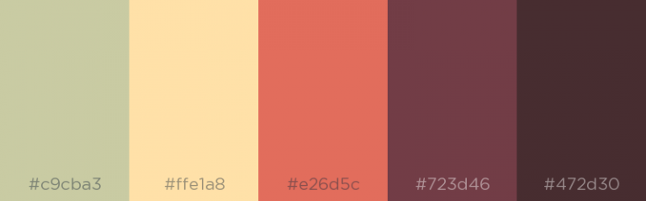

DO IT NOW PHOTO OF WEBPAGE PLACE HOLDER GOES HERE

Signature required on next page
I, Rodrigo Lima , owner of Do It Now Painting and client of Dynamic Unit Web Designs, have selected the above color palette and layout for my website. I understand that any revisions to this part of the project henceforth will affect the budget and schedule of the website’s development.

Client Signature
4/22/2021
X Rodrigo Lima Date ___________________
Client Print Name
4/22/2021
X Rodrigo Lima Date ___________________
Client Signature
Dynamic Unit
4/22/2021
X Tatiana Monaco Date ___________________
Team Syntax Signature (Project Manager)

