Dynamic Unit
1234 Main St, Naperville, Illinois 60955
312-123-456
tmonacochrsitopher@student.morainepark.edu
www.findyourriffle,com/index

Colors and Design
Options

Color Palettes

Color Palette 1

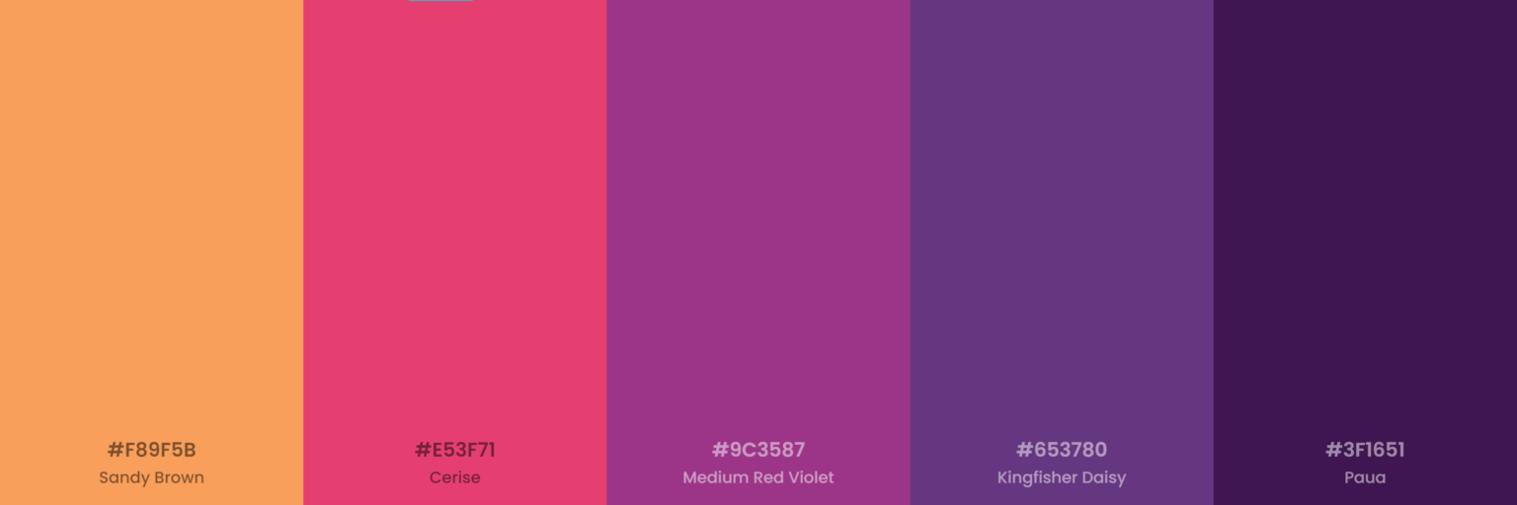

Color Palettes

Color Palette 2

