Dynamic Unit
1234 Main St, Naperville, Illinois 60955
312-123-456
tmonacochrsitopher@student.morainepark.edu
www.findyourriffle,com/index

Update Product Items

Making Changes and Updates

I provided screen captures. These screen captures are showing how I updated and added products and new items to the products. These items being “primer” and “paint”. I just added the “h3” heading, an “ul” list tag and “li tag”. Here below are the pictures of before and after of the code and web page to view changes.

Before:

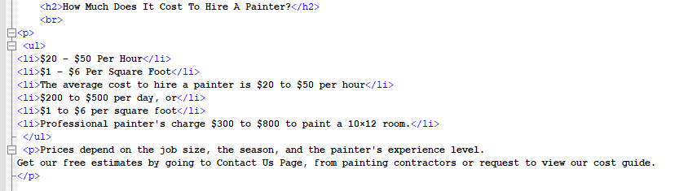


After:

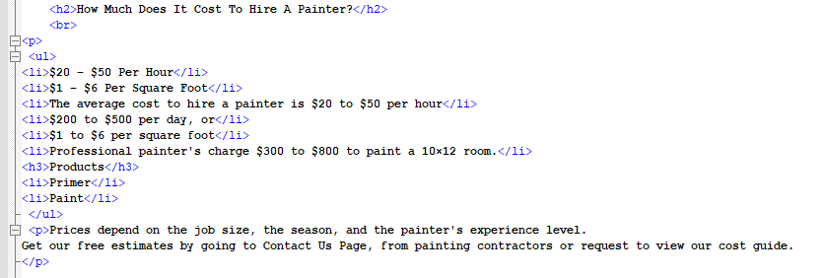
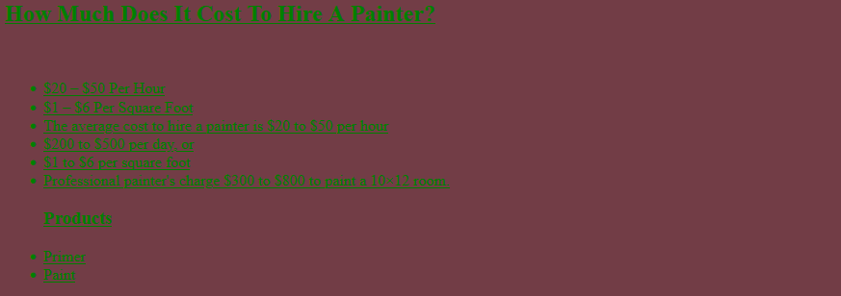

Making Changes and Updates

For these screen captures I showed how to change up the styling for the list. I provided screen captures. For the list I went into the “ul” and added styling to the list with colors, to make it stand out and look more interesting. Also, adding styling to the <ul> tag affects the entire list, while properties added to the <li> tag will affect the individual list items. View screen captures of the code and web page below of before and after.

Before:

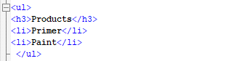


After:

