Dynamic Unit
1234 Main St, Naperville, Illinois 60955
312-123-456
tmonacochrsitopher@student.morainepark.edu
www.findyourriffle,com/index

Domain Name Registration
Plan

Deciding on the Domain Name

Deciding on a domain name is important. This plan will provide recommendations and what to consider in deciding on a domain name. When deciding on a domain name, it’s important to choose something that reflects on and what the business provides like services, business practices and your business or business model. There are multiple benefits to choosing a domain name and having a domain name that reflects your business model. Customers will associate your services and business with your website and domain name. Having a domain name with your business name will help customers find the site easier and boost web traffic. It’s recommended to choose a domain name that’s also the name of your business, or service your business provides to customers for maximum web traffic and business.

Domain Name Suggestions

- www.doitnowpainting.com
- www.paintingdoitnow.com
- www.doitnowpaint.com
- www.doitnowpaintings.com
- www.dinpainting.com
- www.doit-now-painting.com
Domain Name Recommendation
Dynamic Unity recommends the following domain name for Do it Now Painting:
www.doitnowpainting.com

We recommend using .com for the website. It’s the most common domain extension for sites. Using this extension with the business name as the domain, will provide the best results with search engines and for business, visitors, and customers to the website for the business site.
Register a Domain Name

Listed below are 5 Domain Name Registrars for 2022.

Name | Pricing | Major Features | Website
Domain.com | .com = $9.99  .co = $6.99  .net = $12.99 | - Web hosting services  - 2-year purchase, but can manually change | www.domain.com
Bluehost | .com = $12.00  .co = $14.99  .net = $14.99 | - Easy to use  - Marketing services | www.bluehost.com
Namecheap | .com =$12.98  .co = $25.98  .net = $12.98 | - Easy to use  - Web hosting services  - VPN Services | www.namecheap.com
Hover | .com =$12.99  .co = $25.99  .net = $15.49 | - Easy to use  - Provides email address with domains | www.hover.com
GoDaddy | .com =$17.99  .co = $34.99  .net = $19.99 | - Easy to use  - So many services  - Great customer support | www.godaddy.com
(https://themeisle.com/blog/best-domain-registrars/)

Domain Name Registrars Recommendation

Dynamic Unity recommends GoDaddy or using Bluehost domain names and webhosting services.

GoDaddy: Web Hosting and Pricing
Hosting with GoDaddy has many kinds of different services and have 24/7 customer support. It is a great choice.
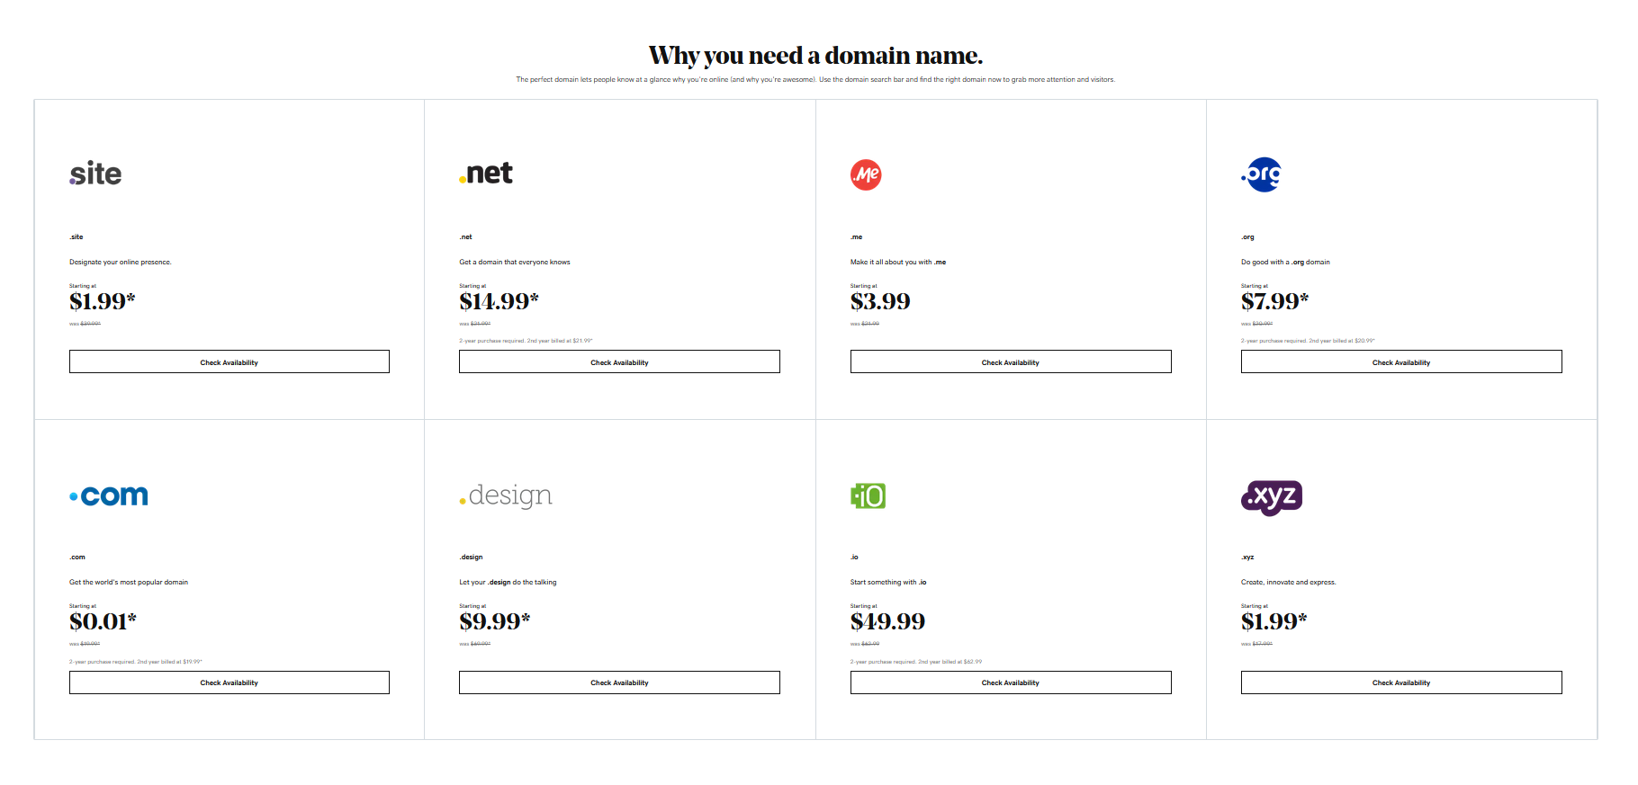
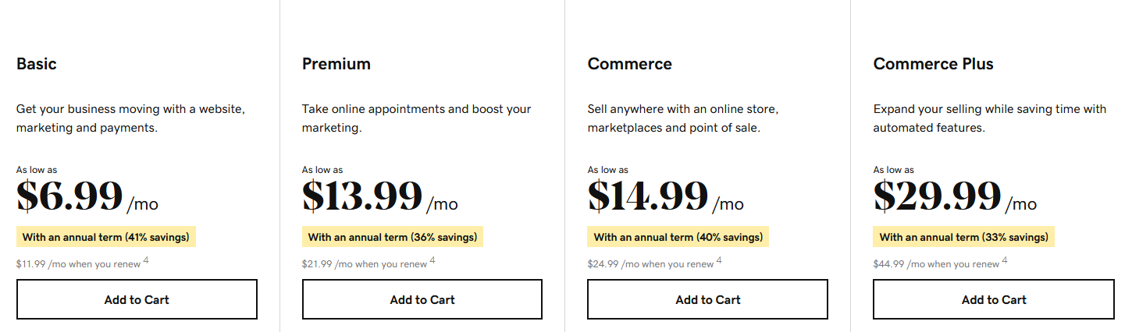

Bluehost: Web Hosting and Pricing
Hosting with Bluehost has multiple kinds of different services and have 24/7 customer support. It is another great choice.

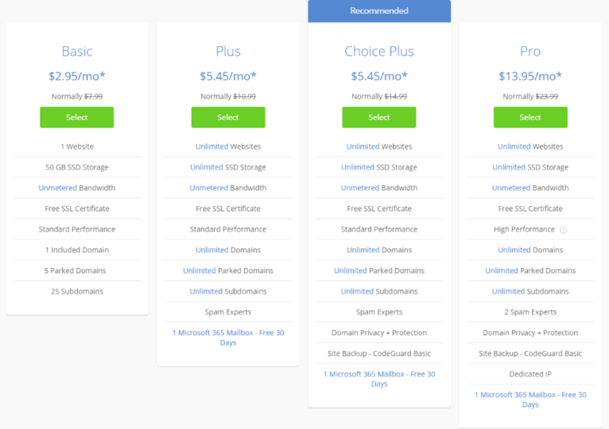
Client Approval

By signing this document, you understand, and agree to the above terms.

Client Signature
29APR2022
X Jose Dias Date ___________________
Client Print Name
29APR2022
X Jose Dias Date ___________________
Client Signature

Dynamic Unity
29APR2022
X Tatiana Monaco Date ___________________
Dynamic Unity Project Manager Name & Signature

