Dynamic Unit
1234 Main St, Naperville, Illinois 60955
312-123-456
tmonacochrsitopher@student.morainepark.edu
www.findyourriffle,com/index

Prepared by: Team Dynamic Unity
May 11, 2022

Quality Assurance: Lead: Nikola
Project Manager: Tatiana Monaco
Creative Lead: Logan Rieman
Technical Lead: Tatiana Monaco

Changing Webpage Content
Materials have been created by Dynamic Unity to help guide you through Do It Now in making changes to the content of their website. We will be focusing on the index.html file and the about.html file

You will need your files and a text editor to view the webpage HTML code. You will copy and paste your index.html file into the text editor.

Now that you can view the HTML Code for the homepage, scroll down to the comment box. You can make changes within the opening and closing <h3></h3> and <p></p> tags. You will also change the heading three tags to News.

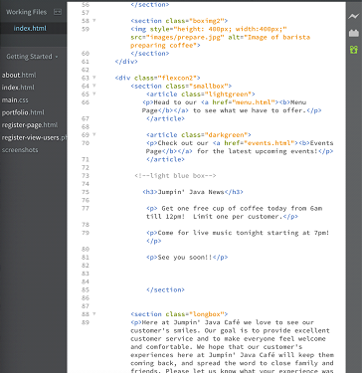

You can view your homepage by double clicking the index.html file. This will allow you to see the changes you have made and saved. You can now delete Do It Now.

Once you have finished deleting Do It Now, you will click on file and within the drop-down menu you will click save. You will then click on the refresh button to view the changes made to your webpage.

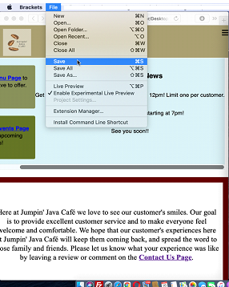

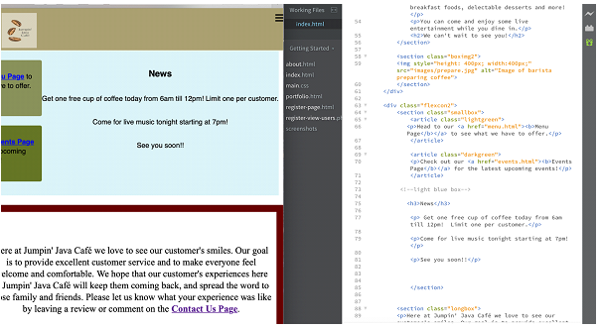

Your final step is to download your changed saved html files to your GoDaddy account. This will allow your content changes to be seen on your live website.

You will need your files and a text editor to view the webpage HTML code. You will drop and drag your about.html file into the text editor, as shown below.

Now that you can view the HTML Code for the about page, scroll down to the comment Café Hours. You can make changes within the opening and closing <h2></h2> and <p></p> tags. You will change Closed Holidays.

You will delete Closed Holidays and type Open July 4th 9am to 4pm. Now you will click on file and within the drop-down menu you will scroll down and click save. You will then click on your refresh button to view the saved changes made to your webpage.

The changed project should be like this:

Your final step is to download your changed saved html files to your GoDaddy account. This will allow your changes to be seen on your live website.

